**Using Azure Text Analytics API for Language Detection**

Create a blank cognitive service

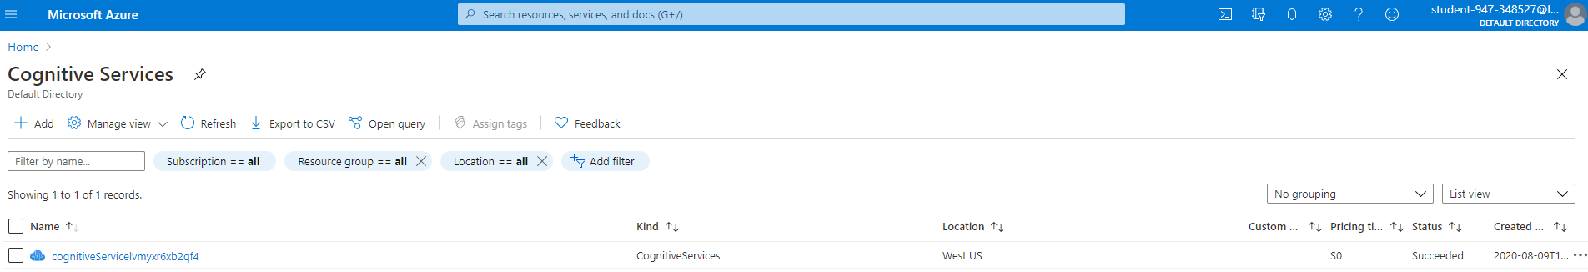

Review keys and endpoint for the API:

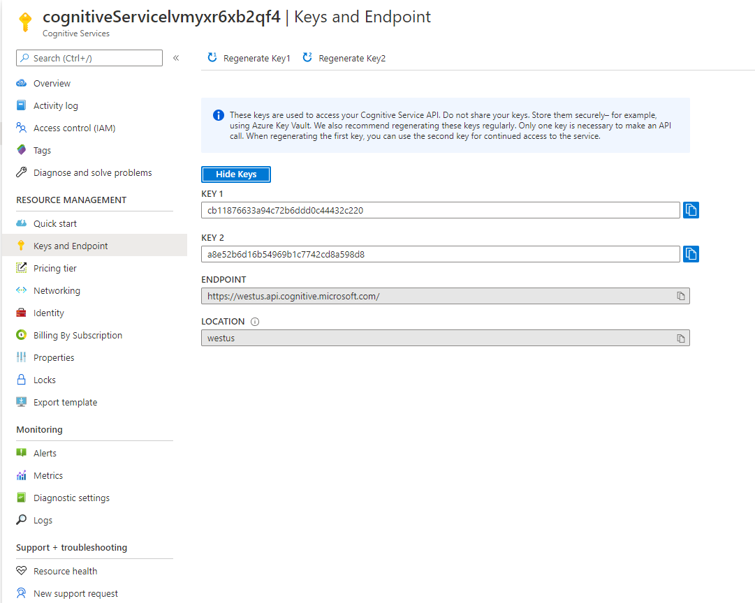

Create a blank function app:

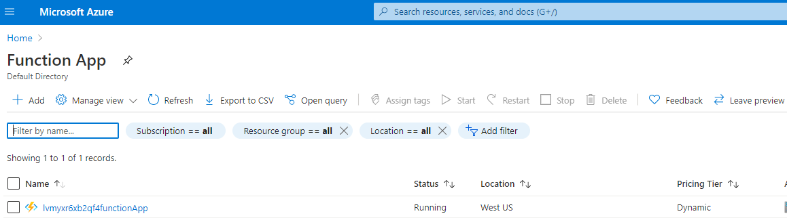

Go to the Function app blade and add a new Function:

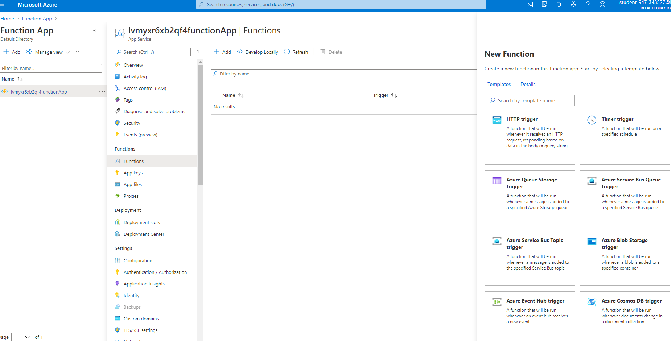

Click HTTP Trigger:

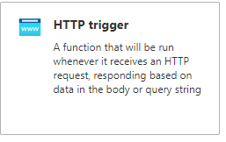

The function will be created as follows:

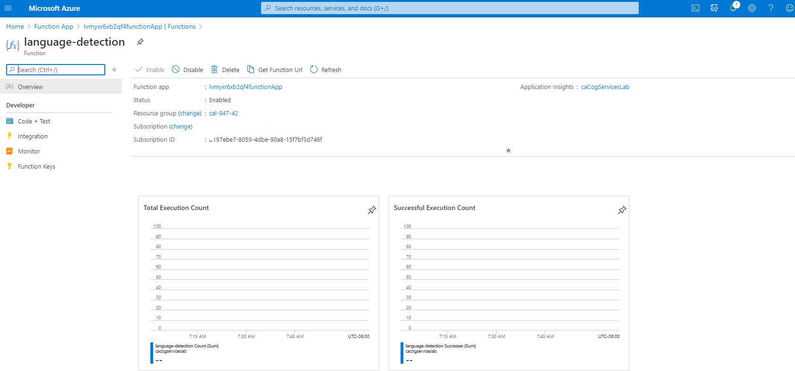

Update the function.json as follows:

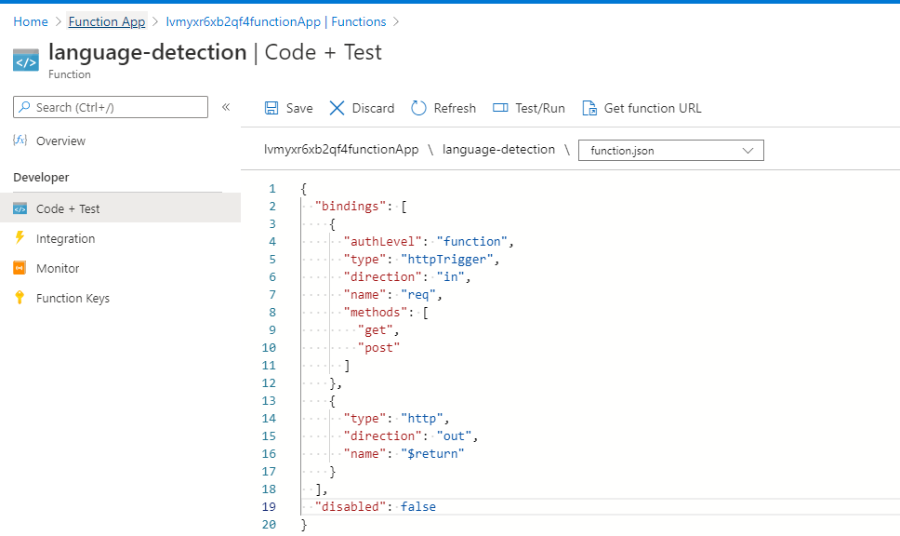

Update the key and endpoint:

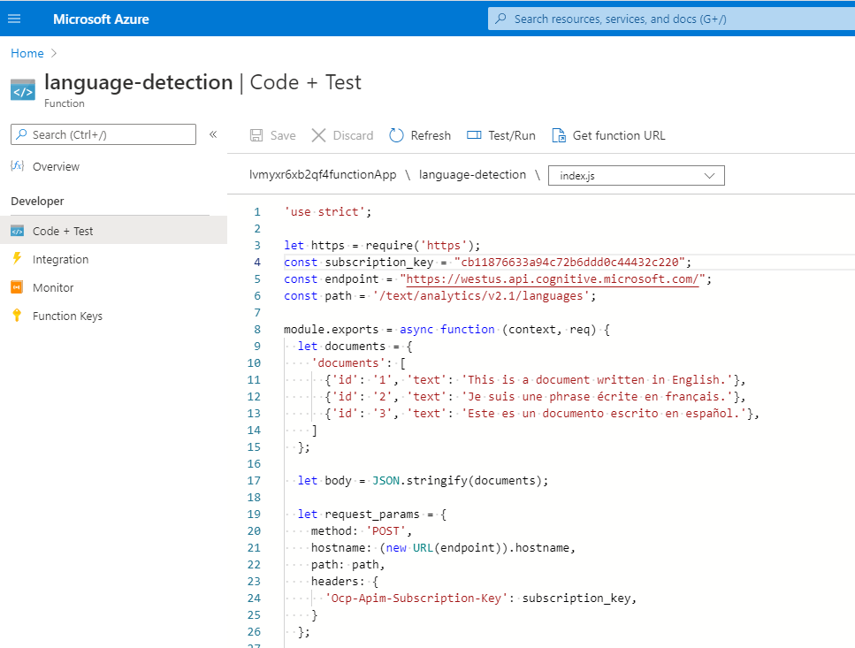

Click “Test/Run”:

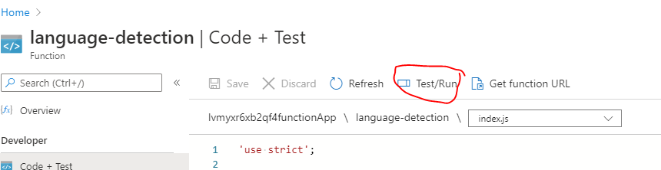

Select GET from HTTP method and click the Run button:

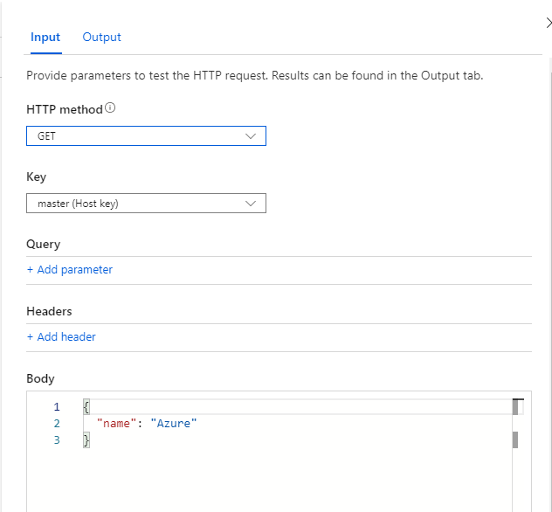

The Output tab shows the following:

